

ASTROMAPS

Submitting in partial fulfilment of the requirements
for the Award of the Degree of

BACHELOR OF SCIENCE (BSc)
Department of Physical Sciences



Submitted by
PEARLENE GRACE (24CPEA26)

Under the Guidance of
Dr JOMOL

DEPARTMENT OF PHYSICAL SCIENCES, KRISTU JAYANTI COLLEGE (AUTONOMOUS)
K. Narayanapura, Kothanur P.O. Bangalore - 560077

DEPARTMENT OF PHYSICAL SCIENCES

CERTIFICATE OF COMPLETION

This is to certify that the project entitled ASTROMAPS has been successfully completed by PEARLENE GRACE (24CPEA26) in partial fulfilment of the award of the Bachelor of Science degree requirements prescribed by Kristu Jayanti (Deemed to be university), Bengaluru in the academic year 2024-27

Internal guide Head of the Department

Valued by Examiners

1._____________________________ Centre: Kristu Jayanti University

2._____________________________ Date:

DECLARATION

I PEARLENE GRACE (24CPEA26) hereby declare that the project work entitled ASTROMAPS is an original project work carried out by me, under the guidance of Ms Jomol S

This Project work has not been submitted earlier to any University/Institution or any other body for the fulfilment of the requirement of a course of study

Signature
PEARLENE GRACE
24CPEA26

Bengaluru
Date:

ACKNOWLEDGEMENT
The success of the project depends upon the efforts invested. It’s my duty to acknowledge and
thank the individuals who has contributed in the successful completion of the project.

Firstly, I thank the Almighty God for giving me strength and good health throughout
my project and enabling me to complete it successfully.

I take this opportunity to express my profound and whole-hearted thanks to Rev.
Fr. Dr. AUGUSTINE GEORGE, VICE CHANCELLOR and Rev. Fr. LIJO P THOMAS, PRO VICE CHANCELLOR and CHIEF FINANCIAL OFFICER, KRISTU JAYANTI
(DEEMED TO BE UNIVERSITY), BENGALURU, for providing ample facilities to undertake my project successfully.
I express my deep sense of gratitude and sincere thanks to our Dean, Dr. SEVUGA PANDIAN
, and Head of the Department of Physical Sciences, Dr Liji George for their valuable
advice.

I feel immense pleasure to thank my respected guide Ms. Jomol S for sustaining interest and
providing dynamic guidance in aiding me to complete this project immaculately and impeccably
and for being the source of my strength and confidence.

It is my duty to express my thanks to all teaching and non-teaching staff members of the computer science department who offered me help directly or indirectly by their suggestions.

The successful completion of my project would not have been possible without my parents’ sacrifice, guidance, and prayers.

I take this opportunity to thank everyone for their continuous encouragement. I convey my thankfulness to all my friends who were with me to share my happiness and agony.

SYNOPSIS

Astromaps is a revolutionary astronomy app that allows both novice astronomers and experts alike to make detailed observations of their night skies. At its core Astromaps acts as a helpful tool to analyse the objects in the night sky for the advantage of many astrophysicists.

Astromaps shows the users the current map of the sky based on their location. It also displays the latest news with regards to space. It will provide a 3D map of the observable universe. It also displays the current weather conditions with respect to the user’s location. It can be used by
stargazers to make accurate observations of the cosmos. It can aid astronomy students in
studying objects in the sky like stars, planets, quasars etc.

For users who want more features they can create an account with their name, email id and
their job status. They will get access to more features. For example, they can add inputs
from their own telescopes (radio and optical) to the software. The software can analyze
their input and catalog the items found, so that the user can study these objects in detail
later.

TABLE OF CONTENTS
Sl No. | Content | Page number
1 | Scope of the Project | 7-8
2 | Modules of the Project | 9
3 | System study | 10
4 | Feasibility study | 11-12
5 | System Design | 13-15
6 | ER Diagram | 16-17
7 | Dataflow Diagram | 17-18
8 | Table design | 19
9 | Gantt Chart | 20
10 | Code | 21-49
11 | System configuration | 50
12 | Testing | 51-54
13 | Frontend – backend overview | 54-61
14 | Conclusion and enhancement | 62

SCOPE OF THE PROJECT
1. Executive Summary & Objective
Astromaps Portal is a web-based astronomical platform designed for amateur astronomers and space photography enthusiasts. The portal delivers a real-time, interactive celestial star map centered on the user's geographic location alongside automated photographic plate-solving and a catalog management database.
The core objective is to provide an all-in-one workspace where users can authenticate, observe live sky positions, search celestial object catalogs, and process astrophotography uploads.
2. Core Functional Requirements
User Management & Security
- Authentication: User registration and secure login via encrypted passwords (using bcryptjs).
- Session Tracking: Associate space photo uploads and catalog records with specific user IDs (users table).
Live Celestial Engine & Viewport
- Dynamic Sky Chart: Real-time star map powered by d3-celestial and D3.js using stereographic projection.
- Geolocation Alignment: Automatic calculation of Local Sidereal Time (LST) and Right Ascension (RA) using GPS coordinates to center the sky directly overhead.
- Photography Overlay: Dynamic switching between the interactive star grid and target high-resolution astrophotography previews.
Catalog Search & Interactive Discovery
- Deep-Sky Database: Real-time catalog search powered by a PostgreSQL backend (celestial_log table) housing objects like Orion (M42), Andromeda (M31), Pleiades (M45), Betelgeuse, and Sirius.
- Instant Target Centering: Selecting or searching an object centers the live view or displays associated high-resolution astronomical images.
Astrophotography Pipeline & Classification
- Image Upload: Direct file upload workflow connecting to user storage logs (userphotos table).
- Plate-Solver Engine: Automated pattern recognition analyzing uploaded sky photos, matching them against known catalogs, and storing classification results (photoclassifications table).
3. Technology Stack & Database Architecture

MODULES IN THE PROJECT:
1.) Web applications and orchestration module
(Javascript) : It handles the main web server, REST API endpoints, user authentication, file uploads and system workflow. It acts as the central coordinator that routes user requests, triggers processing tasks and manages database transactions
2.) Astronomical and analysis engine
Plate-Solving & External Astronomical APIs (Advanced Analysis)
For real-time astrophotography pattern matching (plate-solving), the analysis engine uses key open-source algorithms or external web services:
Specialized Calculation Libraries & APIs
Library / API | Tech Stack | Primary Purpose in Analysis Engine
Astronomy Engine (Optional JS/C#) | JavaScript / C | Light-weight, high-accuracy calculations for planetary positions, rise/set times, eclipses, and coordinate transforms.
Astrometry.net API | External Web Service / C | Industry-standard Plate-Solver. Accepts uploaded space photos, extracts star patterns, calculates World Coordinate System (WCS) coordinates, and identifies matched deep-sky objects (e.g., M42, M31).

3.) Data Storage and special search module – (PostGre SQL)
Manages relational data for user accounts, upload history and catalog metadata. It uses spatial indexing to allow rapid celestial queries such as searching for uploaded obserbations within specific angular distances of target sky coordinates

4.) Telescopic images and photoanalysis (upload)
Handles uploads from user images. It runs background plate solving algorithms to identify celestial coordinates, overlay catallog entities onto the uploaded image and archive solved observations into a searchable database
SYSTEM STUDY
The existing system that I referred is a website called InTheSky.org. It is a website created by an American astronomy enthusiast to display maps of the sky, catalog of celestial objects. Being a webstire it did not require any heavy software installations. It uses the following open-source libraries
  - JSPlot : an open source JavaScript library used for graph plottinf and vector graphics to embed scientific charts inside on the website
  - StarCharter : a command line tool written to generate SVG, PDF and NG star charts for the platform
  - ephemerisCompute: a common backend tool used to calculate and overlay positions of solar system objects like planets and comets.
It also offers location detection through automatic tracking and manual setup.
The astronomical calculations are performed by:
  - Ephemerisdate : it uses precise scientific data primarily planetary predcitions derived from NASA
  - JPL DE440 ephemeris : to compute where objects will appear

Core features:
- Interactive planetarium
- 3D Orrery and Universe map
- Satellite tracking
- Event catalogs

FEASIBILITY STUDY
Feasibility Study: Astromaps Portal
1. Executive Summary & Objective
The Astromaps Portal is an integrated web platform delivering real-time celestial sky mapping, object catalog search, user authentication, and an astrophotography plate-solving workflow. This study evaluates the technical, operational, schedule, and economic viability of deploying the system using Node.js, PostgreSQL, and d3-celestial.
2. Technical Feasibility (Rating: High)
The proposed stack leverages established, open-source web standard technologies:
- Frontend Rendering: d3-celestial and D3.js handle vector-based coordinate projection $\left(\text{RA/Dec}→2\text{D Visuals}\right)$ directly on the client side, keeping computational overhead on the server minimal.
- Backend Architecture: Node.js with Express provides a lightweight REST API for handling user authentication (bcryptjs) and session routing.
- Data Persistence: PostgreSQL (pg connection pool) manages structured relationships efficiently across four core tables (users, celestial_log, userphotos, photoclassifications).
- Plate-Solving Pipeline: Asynchronous integration with external microservices (e.g., Astrometry.net API or local C/Python workers) ensures heavy image pattern-matching tasks run without blocking main thread operations.
Conclusion: The technical stack is fully feasible, well-documented, and utilizes mature libraries.
3. Operational Feasibility (Rating: High)
- User Accessibility: Operates inside standard web browsers without requiring local software installation or specialized client hardware.
- Maintenance & Scalability: PostgreSQL schema design isolates operational logs, allowing straightforward database indexing and future horizontal scaling on cloud infrastructure (e.g., AWS, Render, Heroku).
- Usability: Tabbed authentication and direct catalog lookup streamline the workflow for both amateur stargazers and experienced astrophotographers.
4. Economic & Resource Feasibility (Rating: Highly Cost-Effective)
Resource Category | Primary Stack Components | Cost Estimate
Development Software | Node.js, PostgreSQL, VS Code, Git | $0 (Open-Source)
External APIs | Astrometry.net API, standard catalog datasets | $0 (Free Tier / Public Domain)
Hosting & Database | Cloud VPS / Serverless Database Tier | $0 - $15/month (Initial Deployment)
Conclusion: Minimal overhead makes the project financially low-risk and sustainable.
5. Schedule & Execution Feasibility

Phase 1: Database & Core Server Setup (Completed)
• Schema creation (`users`, `celestial_log`, `userphotos`)
• Node.js + Express API infrastructure (`server.js`, `.env`)

Phase 2: Frontend & Sky Map Integration (Current)
• Registration / Login UI and `d3-celestial` live viewport
• Real-time catalogue lookup and coordinate updates

Phase 3: Plate-Solving Pipeline & Deployment (Target: 2 Weeks)
• Photo upload pipeline & automated Astrometry API background tasks
6. Risk Assessment & Mitigation
- Risk: High latency during photographic plate-solving analysis.
  - Mitigation: Implement asynchronous background jobs with status polling indicators on the frontend.
- Risk: High database load during catalog searches.
  - Mitigation: Index catalog_id and coordinate columns (ra, dec) in PostgreSQL for sub-millisecond lookups.

SYSTEM DESIGN
In the design phase the architecture is established. This phase starts with the requirement
document delivered by the requirement phase and maps the requirements into an architecture.
The architecture defines the components, their interfaces and behaviors. The deliverable design
document is the architecture. The design document describes a plan to implement the
requirements. This phase represents the ``how'' phase
Details on computer programming languages and environments, machines, packages,
application architecture, distributed architecture layering, memory size, platform, algorithms,
data structures, global type definitions, interfaces, and many other engineering details are
established.
The design may include the usage of existing components. Analysing the trade-offs of necessary
complexity allows for many things to remain simple which, in turn, will eventually lead to a
higher quality product. The architecture team also converts the typical scenarios into a test plan.
In our approach, the team, given a complete requirement document, must also indicate critical
priorities for the implementation team.
A critical implementation priority leads to a task that has to be done right. If it fails, the product
fails. If it succeeds, the product might succeed. At the very least, the confidence level of the team
producing a successful product will increase. This will keep the implementation team focused.
Exactly how this information is conveyed is a skill based on experience more than a science
based on fundamental foundations. System design is the process of defining the architecture
components, modules, interfaces, and data for a system to satisfy specified requirements.
Systems design could be seen as the application of systems theory to product development. There
is some overlap with the disciplines of systems analysis, systems architecture and systems
engineering. If the broader topic of product development blends the perspective of marketing,
design, and manufacturing into a single approach to product development," then design is the
act of taking the marketing information and creating the design of the product to be
manufactured. Systems design is therefore the process of defining and developing systems to
satisfy specified requirements of the user. Until the 1990s, systems design had a crucial and
respected role in the data processing industry. In the1990s, standardization of hardware and
software resulted in the ability to build modular systems. The increasing importance ofsoftware
running on generic platforms has enhanced the discipline ofsoftware engineering. Object-oriented
analysis and design methods are becoming the most widely used methods for computer systems
design. The UML has become the standard language in object-oriented analysis and design.

ER DIAGRAM
An entity relationship diagram (ERD) shows the relationships of entity sets stored in a database.
An entity in this context is a component of data. In other words, ER diagrams illustrate the logical structure of databases. At first glance an entity relationship diagram looks very much like a flowchart. It is the specialized symbols, and the meanings of those symbols, that make it unique.
Because this ER tutorial focuses on beginners.
Below are some tips that will help you build effective ER diagrams:
• Identify all the relevant entities in each system and determine the relationships among
these entities.
• An entity should appear only once in a particular diagram.
• Provide a precise and appropriate name for each entity, attribute, and relationship in the diagram.
• Terms that are simple and familiar always beats vague, technical-sounding words.
• In naming entities, remember to use singular nouns. However, adjectives may be used to
distinguish entities belonging to the same class (for example part-time employee and full -time
employee).
• Meanwhile attribute names must be meaningful, unique, system independent, and easily
understandable.
• Remove vague, redundant or unnecessary relationships between entities.
• Never connect a relationship to another relationship.
• Make effective use of colors.
• You can use colors to classify similar entities or to highlight key areas in your diagrams.
• You can draw entity relationship diagrams manually, especially when you are just
informally showing simple systems to your peers.
• However, for more complex systems and for external audiences, you need diagramming
software such as Creately’s to craft visually engaging and precise ER diagrams.
• The ER Diagram Software offered by Creately as an online service is pretty easy to use
and is a lot more affordable than purchasing licensed software.
• It is also perfectly suited for development teams because of its strong support for collaboration.

DATAFLOW DIAGRAM
The Data Flow Diagrams (DFDs) are used for structure analysis and design. DFDs show the
flow of data from external entities into the system. DFDs also show how the data moves and is
transformed from one process to another, as well as its logical storage. The following symbols
are used within DFDs. For clarity, a key has been provided at the bottom of this page.
A data flow diagram (DFD) is a graphical representation of the "flow" of data through an
information system, modelling its process aspects. A DFD is often used as a preliminary step to
create an overview of the system, which can later be elaborated. DFDs can also be used for the
visualization of data processing (structured design).
A DFD shows what kind of information will be input to and output from the system, where the
data will come from and go to, and where the data will be stored. It does not show information
about the timing of process or information about whether processes will operate in sequence or in parallel (which is shown on a flowchart).
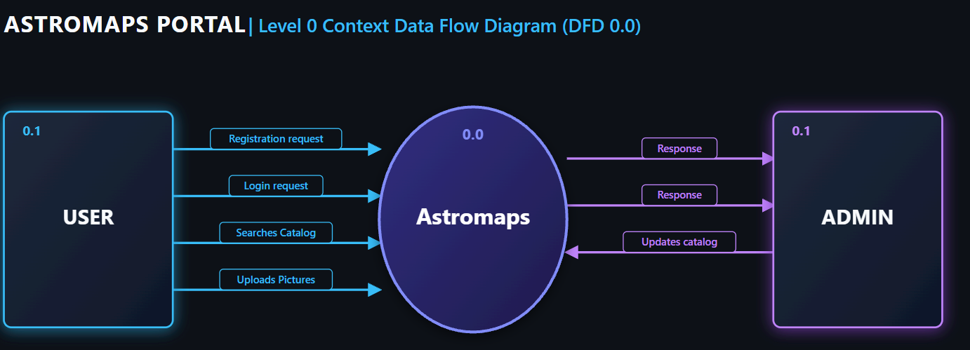

Level 1 DFD’s aim to give an overview of the full system. They look at the system in more
detail. Major processes are broken down into subprocesses. Level 1 DFD’s also identifies data
stores that areused by the major processes. When constructing a Level 1 DFD, we must start
by examining the Context Level DFD.
We must break up the single process into its subprocesses.We must then pick out the data stores from the text we are given and include them in our DFD.
Like the Context Level DFD’s, all entities, data stores and processes must be labelled
We must also state any assumptions made from the text.
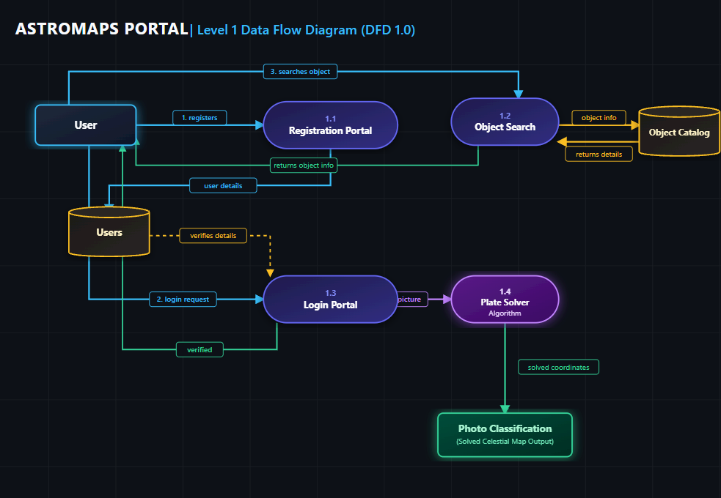

TABLE DESIGN

GANTT CHART
A Gantt chart is a type of bar chart, devised by Henry Gantt in the 1910s, that illustrates a project
schedule. Gantt charts illustrate the start and finish dates of the terminal elements and summary
elements of a project. Terminal elements and summary elements comprise the work breakdown
structure of the project.
Modern Gantt charts also show the dependency (i.e., precedence network) relationships between
activities. Gantt charts can be used to show current schedule status using percent-complete
shadings and a vertical "TODAY" line as shown here.
Although now regarded as a common charting technique, Gantt charts were considered
revolutionary when first introduced. This chart is also used in information technology to represent
data that has been collected.
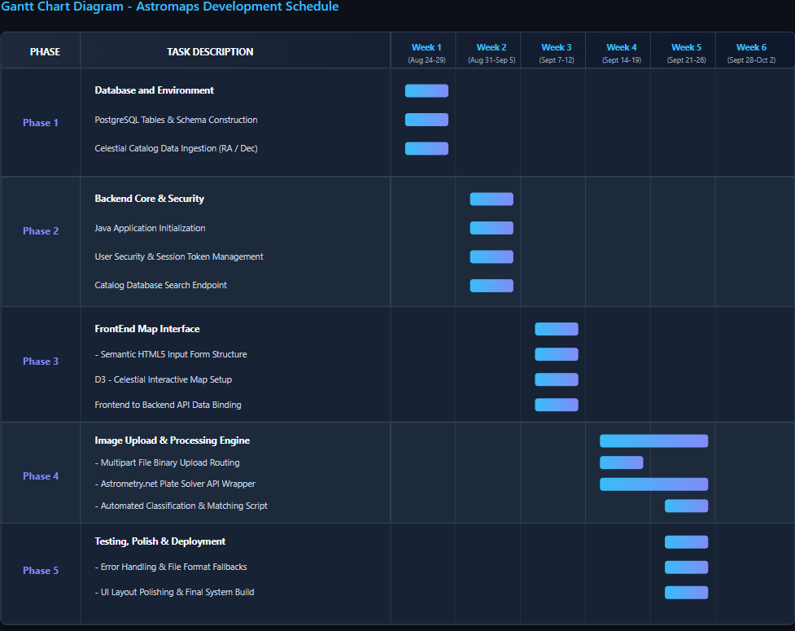

FRONTEND :
// Global State & Map Reference
let map;
let markersGroup;
let isRegisterMode = false;

// Token & User helpers
const getToken = () => localStorage.getItem('astromaps_token');
const getUser = () => JSON.parse(localStorage.getItem('astromaps_user') || 'null');

// Initialize Leaflet Map
function initMap() {
map = L.map('map', {
center: [0, 0],
zoom: 2,
minZoom: 1,
maxZoom: 6
});

// OpenStreetMap tile layer
L.tileLayer('https://{s}.tile.openstreetmap.org/{z}/{x}/{y}.png', {
maxZoom: 18,
attribution: '&copy; OpenStreetMap contributors'
}).addTo(map);

markersGroup = L.layerGroup().addTo(map);
}

// Fetch Sidereal Time from API
async function fetchSiderealTime() {
try {
const response = await fetch('/api/astro/sidereal-time?longitude=0.0');
if (!response.ok) return;
const data = await response.json();

document.getElementById('gstVal').textContent = `${data.gstHours}h`;
document.getElementById('lstVal').textContent = `${data.lstHours}h`;
document.getElementById('zenithVal').textContent = `${data.zenithRA}h`;
} catch (err) {
console.error('Failed to fetch sidereal time:', err);
}
}

// Search Catalog Objects via API
async function searchCatalog() {
const query = document.getElementById('searchInput').value.trim();
const resultsContainer = document.getElementById('resultsList');
if (!query) return;

resultsContainer.innerHTML = '<p class="text-slate-400 text-sm">Searching...</p>';
markersGroup.clearLayers();

try {
const response = await fetch(`/api/astro/catalog/search?query=${encodeURIComponent(query)}`);
const results = await response.json();

resultsContainer.innerHTML = '';

if (!Array.isArray(results) || results.length === 0) {
resultsContainer.innerHTML = '<p class="text-amber-400 text-sm">No celestial targets found.</p>';
return;
}

const token = getToken();

results.forEach(obj => {
const card = document.createElement('div');
card.className = 'p-3 bg-slate-950 border border-slate-800 rounded-lg hover:border-indigo-500 transition space-y-2';
card.innerHTML = `
<div class="flex justify-between items-start">
<h3 class="font-bold text-indigo-300 text-sm cursor-pointer hover:underline">${obj.catalog_id} - ${obj.object_name}</h3>
<span class="text-xs bg-slate-800 text-slate-300 px-2 py-0.5 rounded">${obj.type}</span>
</div>
<p class="text-xs text-slate-400">RA: <span class="text-slate-200">${obj.ra}°</span> | Dec: <span class="text-slate-200">${obj.dec}°</span></p>
${token ? `
<button type="button" class="saveTargetBtn text-xs bg-slate-800 hover:bg-indigo-600 text-slate-200 px-2 py-1 rounded w-full transition cursor-pointer" data-id="${obj.catalog_id}" data-name="${obj.object_name}">
⭐ Bookmark Target
</button>
` : ''}
`;

card.querySelector('h3').addEventListener('click', () => {
map.setView([obj.dec, obj.ra], 4);
});

const saveBtn = card.querySelector('.saveTargetBtn');
if (saveBtn) {
saveBtn.addEventListener('click', () => saveTarget(obj.catalog_id, obj.object_name));
}

resultsContainer.appendChild(card);

const marker = L.circleMarker([obj.dec, obj.ra], {
color: '#818cf8',
radius: 8,
fillColor: '#6366f1',
fillOpacity: 0.8
});
marker.bindPopup(`<strong>${obj.catalog_id} (${obj.object_name})</strong><br/>RA: ${obj.ra}° | Dec: ${obj.dec}°`);
markersGroup.addLayer(marker);
});

} catch (err) {
console.error('Search error:', err);
resultsContainer.innerHTML = '<p class="text-rose-400 text-sm">Error querying server.</p>';
}
}

// Save Target Bookmark
async function saveTarget(catalog_id, object_name) {
const token = getToken();
if (!token) return alert('Please login to save targets.');

try {
const response = await fetch('/api/targets/save', {
method: 'POST',
headers: {
'Content-Type': 'application/json',
'Authorization': `Bearer ${token}`
},
body: JSON.stringify({ catalog_id, object_name, notes: 'Saved from catalog search' })
});

if (response.ok) {
fetchSavedTargets();
alert(`Bookmark saved: ${catalog_id}`);
} else {
const data = await response.json();
alert(data.error || 'Failed to save target.');
}
} catch (err) {
console.error('Save failed:', err);
}
}

// Fetch Saved Targets
async function fetchSavedTargets() {
const token = getToken();
const savedContainer = document.getElementById('savedList');
const savedCount = document.getElementById('savedCount');

if (!token) {
savedContainer.innerHTML = '<p class="text-slate-500 text-sm italic">Log in to view your saved targets.</p>';
savedCount.textContent = '0';
return;
}

try {
const response = await fetch('/api/targets', {
headers: { 'Authorization': `Bearer ${token}` }
});
const targets = await response.json();

if (!Array.isArray(targets)) {
savedContainer.innerHTML = '<p class="text-rose-400 text-sm">Failed to load saved targets.</p>';
return;
}

savedCount.textContent = targets.length;
savedContainer.innerHTML = '';

if (targets.length === 0) {
savedContainer.innerHTML = '<p class="text-slate-500 text-sm italic">No targets bookmarked yet.</p>';
return;
}

targets.forEach(t => {
const card = document.createElement('div');
card.className = 'p-3 bg-slate-950 border border-slate-800 rounded-lg flex justify-between items-center';
card.innerHTML = `
<div>
<h4 class="font-bold text-indigo-300 text-sm">${t.catalog_id} - ${t.object_name}</h4>
<p class="text-xs text-slate-400">${t.notes || 'No notes'}</p>
</div>
<button type="button" class="deleteBtn text-xs text-rose-400 hover:text-rose-300 p-1 cursor-pointer">Delete</button>
`;

card.querySelector('.deleteBtn').addEventListener('click', () => deleteTarget(t.id));
savedContainer.appendChild(card);
});

} catch (err) {
console.error('Failed to load saved targets:', err);
}
}

// Delete Target Bookmark
async function deleteTarget(id) {
const token = getToken();
try {
await fetch(`/api/targets/${id}`, {
method: 'DELETE',
headers: { 'Authorization': `Bearer ${token}` }
});
fetchSavedTargets();
} catch (err) {
console.error('Delete failed:', err);
}
}

// UI State Management
function updateAuthUI() {
const user = getUser();
const openAuthBtn = document.getElementById('openAuthBtn');
const userInfo = document.getElementById('userInfo');
const userGreeting = document.getElementById('userGreeting');

if (user) {
openAuthBtn.classList.add('hidden');
userInfo.classList.remove('hidden');
userGreeting.textContent = `👤 ${user.username}`;
fetchSavedTargets();
} else {
openAuthBtn.classList.remove('hidden');
userInfo.classList.add('hidden');
document.getElementById('savedCount').textContent = '0';
}
}

// Event Listeners Initialization
document.addEventListener('DOMContentLoaded', () => {
initMap();
fetchSiderealTime();
setInterval(fetchSiderealTime, 10000);
updateAuthUI();

// Modal Control Handlers
const authModal = document.getElementById('authModal');
const openAuthBtn = document.getElementById('openAuthBtn');
const closeAuthModal = document.getElementById('closeAuthModal');

if (openAuthBtn && authModal) {
openAuthBtn.addEventListener('click', (e) => {
e.preventDefault();
authModal.classList.remove('hidden');
});
}

if (closeAuthModal && authModal) {
closeAuthModal.addEventListener('click', () => {
authModal.classList.add('hidden');
});
}

// Search Control Handlers
document.getElementById('searchBtn').addEventListener('click', searchCatalog);
document.getElementById('searchInput').addEventListener('keypress', (e) => {
if (e.key === 'Enter') searchCatalog();
});

// Tab Switcher Handlers
const tabSearch = document.getElementById('tabSearch');
const tabSaved = document.getElementById('tabSaved');
const tabSolve = document.getElementById('tabSolve');
const panelSearch = document.getElementById('panelSearch');
const panelSaved = document.getElementById('panelSaved');
const panelSolve = document.getElementById('panelSolve');

tabSearch.addEventListener('click', () => {
tabSearch.className = 'text-xs font-semibold text-indigo-400 border-b-2 border-indigo-500 pb-1 cursor-pointer';
tabSaved.className = 'text-xs font-semibold text-slate-400 hover:text-slate-200 border-b-2 border-transparent pb-1 cursor-pointer';
tabSolve.className = 'text-xs font-semibold text-slate-400 hover:text-slate-200 border-b-2 border-transparent pb-1 cursor-pointer';

panelSearch.classList.remove('hidden');
panelSaved.classList.add('hidden');
panelSolve.classList.add('hidden');
});

tabSaved.addEventListener('click', () => {
tabSaved.className = 'text-xs font-semibold text-indigo-400 border-b-2 border-indigo-500 pb-1 cursor-pointer';
tabSearch.className = 'text-xs font-semibold text-slate-400 hover:text-slate-200 border-b-2 border-transparent pb-1 cursor-pointer';
tabSolve.className = 'text-xs font-semibold text-slate-400 hover:text-slate-200 border-b-2 border-transparent pb-1 cursor-pointer';

panelSaved.classList.remove('hidden');
panelSearch.classList.add('hidden');
panelSolve.classList.add('hidden');
fetchSavedTargets();
});

tabSolve.addEventListener('click', () => {
tabSolve.className = 'text-xs font-semibold text-indigo-400 border-b-2 border-indigo-500 pb-1 cursor-pointer';
tabSearch.className = 'text-xs font-semibold text-slate-400 hover:text-slate-200 border-b-2 border-transparent pb-1 cursor-pointer';
tabSaved.className = 'text-xs font-semibold text-slate-400 hover:text-slate-200 border-b-2 border-transparent pb-1 cursor-pointer';

panelSolve.classList.remove('hidden');
panelSearch.classList.add('hidden');
panelSaved.classList.add('hidden');
});

// Image Solve Form Submission Handler
const solveForm = document.getElementById('solveForm');
if (solveForm) {
solveForm.addEventListener('submit', async (e) => {
e.preventDefault();
const fileInput = document.getElementById('solverImageInput');
const solveBtn = document.getElementById('solveBtn');
const solverOutput = document.getElementById('solverOutput');

if (!fileInput.files[0]) return;

const formData = new FormData();
formData.append('image', fileInput.files[0]);

solveBtn.textContent = 'Solving Celestial Field...';
solveBtn.disabled = true;

try {
const response = await fetch('/api/solver/upload', {
method: 'POST',
body: formData
});

const data = await response.json();

if (response.ok && data.status === 'SUCCESS') {
document.getElementById('solvedTarget').textContent = data.matched_object;
document.getElementById('solvedRA').textContent = data.solved_center.ra_deg;
document.getElementById('solvedDec').textContent = data.solved_center.dec_deg;
solverOutput.classList.remove('hidden');

// Plot Marker on Map
const marker = L.circleMarker([data.solved_center.dec_deg, data.solved_center.ra_deg], {
color: '#10b981',
radius: 10,
fillColor: '#34d399',
fillOpacity: 0.8
}).bindPopup(`<strong>Solved Target: ${data.matched_object}</strong>`);

markersGroup.addLayer(marker);
map.setView([data.solved_center.dec_deg, data.solved_center.ra_deg], 4);
} else {
alert(data.error || 'Plate solving failed.');
}
} catch (err) {
console.error('Solve error:', err);
alert('Error connecting to solver service.');
} finally {
solveBtn.textContent = 'Run Plate Solver';
solveBtn.disabled = false;
}
});
}

// Modal Mode Toggle
const toggleAuthModeBtn = document.getElementById('toggleAuthModeBtn');
const modalTitle = document.getElementById('modalTitle');
const usernameField = document.getElementById('usernameField');
const authSubmitBtn = document.getElementById('authSubmitBtn');
const authToggleMsg = document.getElementById('authToggleMsg');

toggleAuthModeBtn.addEventListener('click', () => {
isRegisterMode = !isRegisterMode;
if (isRegisterMode) {
modalTitle.textContent = 'Create Account';
usernameField.classList.remove('hidden');
authSubmitBtn.textContent = 'Register';
authToggleMsg.textContent = 'Already have an account?';
toggleAuthModeBtn.textContent = 'Sign in';
} else {
modalTitle.textContent = 'Account Login';
usernameField.classList.add('hidden');
authSubmitBtn.textContent = 'Sign In';
authToggleMsg.textContent = "Don't have an account?";
toggleAuthModeBtn.textContent = 'Register here';
}
});

// Authentication Submission
document.getElementById('authForm').addEventListener('submit', async (e) => {
e.preventDefault();
const email = document.getElementById('authEmail').value;
const password = document.getElementById('authPassword').value;
const username = document.getElementById('authUsername').value;
const authError = document.getElementById('authError');

const endpoint = isRegisterMode ? '/api/auth/register' : '/api/auth/login';
const payload = isRegisterMode ? { username, email, password } : { email, password };

try {
const response = await fetch(endpoint, {
method: 'POST',
headers: { 'Content-Type': 'application/json' },
body: JSON.stringify(payload)
});

const data = await response.json();

if (!response.ok) {
authError.textContent = data.error || 'Authentication failed.';
authError.classList.remove('hidden');
return;
}

localStorage.setItem('astromaps_token', data.token);
localStorage.setItem('astromaps_user', JSON.stringify(data.user));

authError.classList.add('hidden');
authModal.classList.add('hidden');
updateAuthUI();
} catch (err) {
console.error('Auth error:', err);
authError.textContent = 'Network error during authentication.';
authError.classList.remove('hidden');
}
});

// Logout
document.getElementById('logoutBtn').addEventListener('click', () => {
localStorage.removeItem('astromaps_token');
localStorage.removeItem('astromaps_user');
updateAuthUI();
searchCatalog();
});
});

HTML
<!DOCTYPE html>
<html lang="en" class="dark">
<head>
<meta charset="UTF-8">
<meta name="viewport" content="width=device-width, initial-scale=1.0">
<title>Astromaps - Celestial Control Dashboard</title>

<!-- Tailwind CSS CDN -->
<script src="https://cdn.tailwindcss.com"></script>

<!-- Leaflet CSS & JS -->
<link rel="stylesheet" href="https://unpkg.com/leaflet@1.9.4/dist/leaflet.css" />
<script src="https://unpkg.com/leaflet@1.9.4/dist/leaflet.js"></script>

<style>
#map { height: 500px; }
/* Invert tile brightness slightly for dark chart aesthetic */
.leaflet-tile-container { filter: invert(100%) hue-rotate(180deg) brightness(95%) contrast(90%); }
</style>
</head>
<body class="bg-slate-950 text-slate-100 font-sans min-h-screen flex flex-col">

<!-- Header / Navigation -->
<header class="border-b border-slate-800 bg-slate-900/50 backdrop-blur px-6 py-4 flex items-center justify-between">
<div class="flex items-center space-x-3">
<span class="text-2xl">🌌</span>
<h1 class="text-xl font-bold tracking-wider text-indigo-400">ASTROMAPS <span class="text-xs text-slate-400 font-normal">v1.1</span></h1>
</div>

<!-- Real-time Sidereal Status Bar -->
<div class="hidden md:flex items-center space-x-6 text-sm bg-slate-900 border border-slate-800 px-4 py-2 rounded-lg">
<div><span class="text-slate-400">GST:</span> <span id="gstVal" class="font-mono text-indigo-300 ml-1">--:--</span></div>
<div><span class="text-slate-400">LST:</span> <span id="lstVal" class="font-mono text-emerald-400 ml-1">--:--</span></div>
<div><span class="text-slate-400">Zenith RA:</span> <span id="zenithVal" class="font-mono text-amber-300 ml-1">--:--</span></div>
</div>

<!-- User Auth Controls -->
<div id="authContainer" class="flex items-center space-x-3">
<button id="openAuthBtn" type="button" class="bg-indigo-600 hover:bg-indigo-500 text-white px-4 py-2 rounded-lg text-sm font-medium transition cursor-pointer">
Login / Register
</button>
<div id="userInfo" class="hidden flex items-center space-x-3">
<span id="userGreeting" class="text-sm font-medium text-slate-300"></span>
<button id="logoutBtn" type="button" class="bg-slate-800 hover:bg-slate-700 text-slate-300 px-3 py-1.5 rounded-lg text-xs font-medium transition cursor-pointer">
Logout
</button>
</div>
</div>
</header>

<!-- Main Dashboard Grid -->
<main class="flex-1 p-6 grid grid-cols-1 lg:grid-cols-3 gap-6">

<!-- Left Column: Search, Saved Targets & Solve Image Sidebar -->
<section class="bg-slate-900 border border-slate-800 rounded-xl p-5 flex flex-col space-y-4">

<!-- Tab Controls -->
<div class="flex border-b border-slate-800 pb-2 space-x-4">
<button id="tabSearch" type="button" class="text-xs font-semibold text-indigo-400 border-b-2 border-indigo-500 pb-1 cursor-pointer">
Catalog Search
</button>
<button id="tabSaved" type="button" class="text-xs font-semibold text-slate-400 hover:text-slate-200 border-b-2 border-transparent pb-1 cursor-pointer">
Saved Targets (<span id="savedCount">0</span>)
</button>
<button id="tabSolve" type="button" class="text-xs font-semibold text-slate-400 hover:text-slate-200 border-b-2 border-transparent pb-1 cursor-pointer">
Solve Image
</button>
</div>

<!-- Search Panel -->
<div id="panelSearch" class="flex flex-col space-y-4 flex-1">
<div class="flex space-x-2">
<input
type="text"
id="searchInput"
placeholder="e.g., M42, Orion, Andromeda..."
class="flex-1 bg-slate-950 border border-slate-700 rounded-lg px-3 py-2 text-sm text-slate-100 focus:outline-none focus:border-indigo-500"
/>
<button id="searchBtn" type="button" class="bg-indigo-600 hover:bg-indigo-500 text-white px-4 py-2 rounded-lg text-sm font-medium transition cursor-pointer">
Search
</button>
</div>
<div class="flex-1 overflow-y-auto max-h-[380px] space-y-2" id="resultsList">
<p class="text-slate-500 text-sm italic">Search for celestial targets to display coordinates...</p>
</div>
</div>

<!-- Saved Targets Panel -->
<div id="panelSaved" class="hidden flex flex-col space-y-4 flex-1">
<div class="flex-1 overflow-y-auto max-h-[420px] space-y-2" id="savedList">
<p class="text-slate-500 text-sm italic">Log in to view your saved targets.</p>
</div>
</div>

<!-- Solve Image Panel -->
<div id="panelSolve" class="hidden flex flex-col space-y-4 flex-1">
<form id="solveForm" class="space-y-3">
<label class="block text-xs text-slate-400">Upload Astronomical Image (.jpg, .png, .fits)</label>
<input type="file" id="solverImageInput" accept=".jpg,.jpeg,.png,.fits" required class="w-full text-xs text-slate-300 bg-slate-950 border border-slate-700 rounded-lg p-2 focus:outline-none focus:border-indigo-500 cursor-pointer" />
<button type="submit" id="solveBtn" class="w-full bg-indigo-600 hover:bg-indigo-500 text-white font-medium py-2 rounded-lg text-xs transition cursor-pointer">
Run Plate Solver
</button>
</form>
<div id="solverOutput" class="p-3 bg-slate-950 border border-slate-800 rounded-lg text-xs space-y-1 hidden">
<h4 class="font-bold text-emerald-400">Solve Result:</h4>
<p class="text-slate-300">Target: <span id="solvedTarget" class="text-indigo-300 font-semibold"></span></p>
<p class="text-slate-300">RA: <span id="solvedRA" class="text-slate-100"></span>° | Dec: <span id="solvedDec" class="text-slate-100"></span>°</p>
</div>
</div>

</section>

<!-- Right Column: Interactive Sky Projection Map -->
<section class="lg:col-span-2 bg-slate-900 border border-slate-800 rounded-xl p-5 flex flex-col space-y-4">
<div class="flex items-center justify-between">
<h2 class="text-lg font-semibold text-slate-200">Sky Chart Projection</h2>
<span class="text-xs text-slate-400">RA/Dec Map Projection</span>
</div>
<div id="map" class="w-full rounded-lg border border-slate-800 overflow-hidden"></div>
</section>

</main>

<!-- Authentication Modal (High z-index to overlay map) -->
<div id="authModal" class="hidden fixed inset-0 bg-black/80 backdrop-blur-md z-[9999] flex items-center justify-center p-4">
<div class="bg-slate-900 border border-slate-800 rounded-xl w-full max-w-md p-6 relative space-y-5">

<!-- Close Modal Button -->
<button id="closeAuthModal" type="button" class="absolute top-4 right-4 text-slate-400 hover:text-white text-xl cursor-pointer">&times;</button>

<!-- Modal Title -->
<h2 id="modalTitle" class="text-xl font-bold text-indigo-400">Account Login</h2>

<!-- Auth Form -->
<form id="authForm" class="space-y-4">
<div id="usernameField" class="hidden">
<label class="block text-xs text-slate-400 mb-1">Username</label>
<input type="text" id="authUsername" class="w-full bg-slate-950 border border-slate-700 rounded-lg px-3 py-2 text-sm text-slate-100 focus:outline-none focus:border-indigo-500" placeholder="e.g. astronomer1">
</div>

<div>
<label class="block text-xs text-slate-400 mb-1">Email Address</label>
<input type="email" id="authEmail" required class="w-full bg-slate-950 border border-slate-700 rounded-lg px-3 py-2 text-sm text-slate-100 focus:outline-none focus:border-indigo-500" placeholder="astro@sky.com">
</div>

<div>
<label class="block text-xs text-slate-400 mb-1">Password</label>
<input type="password" id="authPassword" required class="w-full bg-slate-950 border border-slate-700 rounded-lg px-3 py-2 text-sm text-slate-100 focus:outline-none focus:border-indigo-500" placeholder="••••••••">
</div>
<div id="authError" class="text-xs text-rose-400 hidden"></div>
<button type="submit" id="authSubmitBtn" class="w-full bg-indigo-600 hover:bg-indigo-500 text-white font-medium py-2 rounded-lg text-sm transition cursor-pointer">
Sign In
</button>
</form>
<!-- Toggle Mode -->
<p class="text-xs text-center text-slate-400">
<span id="authToggleMsg">Don't have an account?</span>
<button id="toggleAuthModeBtn" type="button" class="text-indigo-400 font-semibold ml-1 underline cursor-pointer">Register here</button>
</p>
</div>
</div>
<script src="/app.js"></script>
</body>
</html>
DASHBOARD DESIGN
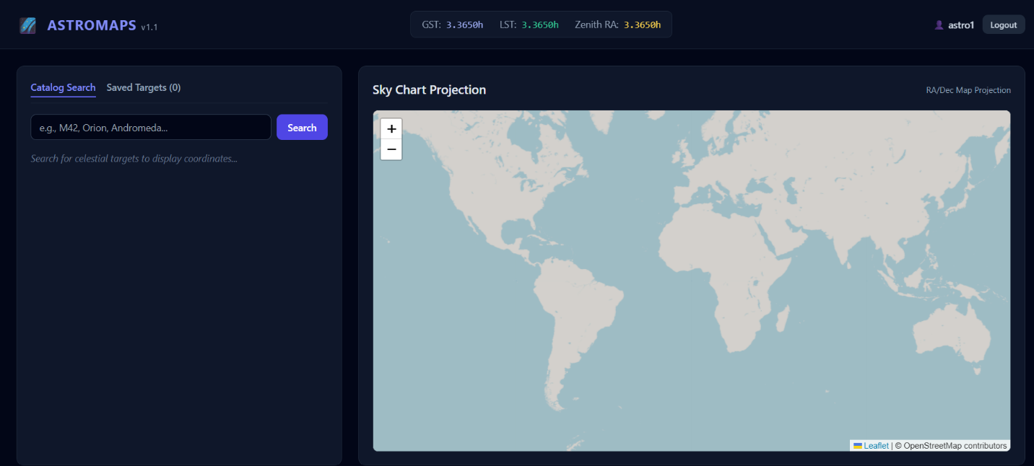

POSTGRESQL
CREATE DATABASE astromaps_db;

\c astromaps_db;

CREATE TABLE IF NOT EXISTS celestial_objects (
id SERIAL PRIMARY KEY,
catalog_id VARCHAR(50) UNIQUE NOT NULL,
object_name VARCHAR(100) NOT NULL,
ra DECIMAL(9,6) NOT NULL,
dec DECIMAL(9,6) NOT NULL,
type VARCHAR(50)
);
-- Users table
CREATE TABLE IF NOT EXISTS users (
id SERIAL PRIMARY KEY,
username VARCHAR(50) UNIQUE NOT NULL,
email VARCHAR(100) UNIQUE NOT NULL,
password_hash VARCHAR(255) NOT NULL,
created_at TIMESTAMP DEFAULT CURRENT_TIMESTAMP
);

-- Saved Targets (Bookmarks) table
CREATE TABLE IF NOT EXISTS user_photos (
id SERIAL PRIMARY KEY,
user_id INT REFERENCES users(id) ON DELETE CASCADE,
catalog_id VARCHAR(50) NOT NULL,
object_name VARCHAR(100) NOT NULL,
notes TEXT,
saved_at TIMESTAMP DEFAULT CURRENT_TIMESTAMP,
UNIQUE(user_id, catalog_id)
);

INSERT INTO celestial_objects (catalog_id, object_name, ra, dec, type)
VALUES
('M42', 'Orion Nebula', 83.8221, -5.2333, 'Emission Nebula'),
('M31', 'Andromeda Galaxy', 10.6847, 41.2687, 'Spiral Galaxy'),
('M1', 'Crab Nebula', 83.6331, 22.0145, 'Supernova Remnant'),
('M8', 'Lagoon Nebula', 270.9213, -24.3803, 'Emission Nebula'),
('M13', 'Hercules Cluster', 250.4218, 36.4603, 'Globular Cluster'),
('M16', 'Eagle Nebula', 274.7000, -13.8070, 'Emission Nebula'),
('M20', 'Trifid Nebula', 270.6300, -23.0300, 'Emission/Reflection Nebula'),
('M27', 'Dumbbell Nebula', 299.9015, 22.7212, 'Planetary Nebula'),
('M33', 'Triangulum Galaxy', 23.4621, 30.6602, 'Spiral Galaxy'),
('M44', 'Beehive Cluster', 130.1000, 19.6700, 'Open Cluster'),
('M45', 'Pleiades', 56.8700, 24.1050, 'Open Cluster'),
('M51', 'Whirlpool Galaxy', 202.4696, 47.1953, 'Spiral Galaxy'),
('M57', 'Ring Nebula', 283.3962, 33.0292, 'Planetary Nebula'),
('M81', 'Bode''s Galaxy', 148.8882, 69.0653, 'Spiral Galaxy'),
('M82', 'Cigar Galaxy', 148.9684, 69.6797, 'Starburst Galaxy'),
('M101', 'Pinwheel Galaxy', 210.8024, 54.3489, 'Spiral Galaxy'),
('M104', 'Sombrero Galaxy', 189.9976, -11.6231, 'Spiral Galaxy'),
('NGC 7000', 'North America Nebula', 314.7000, 44.3300, 'Emission Nebula'),
('NGC 869', 'Double Cluster (Perseus Alpha)', 34.7500, 57.1300, 'Open Cluster'),
('NGC 2237', 'Rosette Nebula', 97.9800, 4.9800, 'Emission Nebula'),
('NGC 6960', 'Veil Nebula (Western)', 311.8700, 30.7200, 'Supernova Remnant'),
('C 33', 'Veil Nebula (Eastern)', 311.5000, 31.7200, 'Supernova Remnant');
ON CONFLICT (catalog_id) DO NOTHING;

TABLES
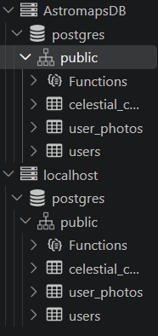

INPUT FORM DESIGN
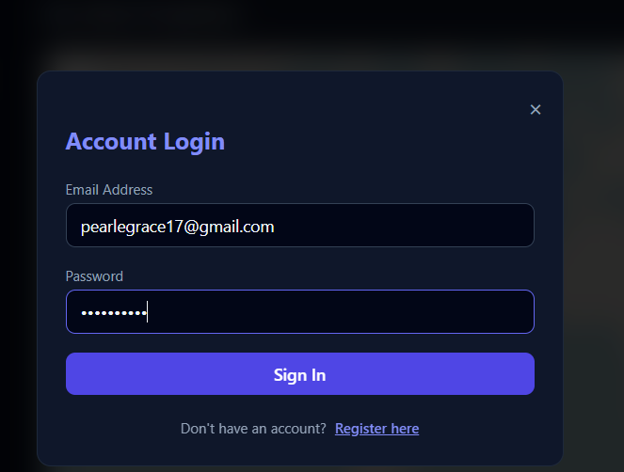
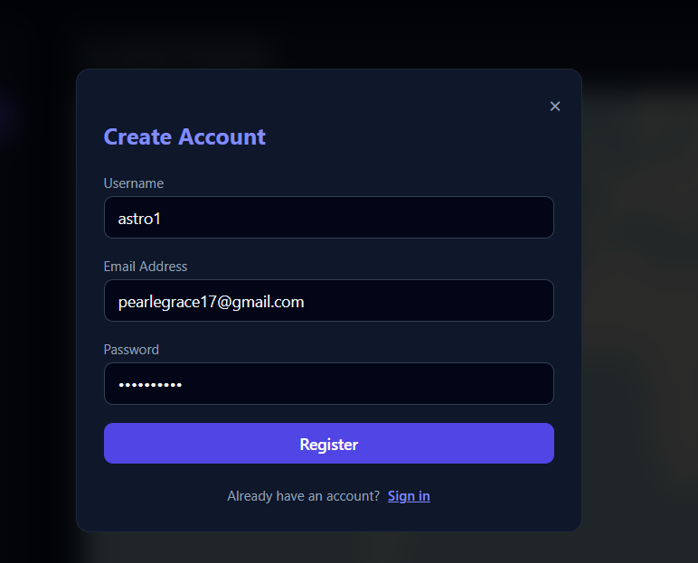

PLATE SOLVER CODE
const path = require("path");

// Pre-indexed catalog for coordinate mapping
const CATALOG = [
{ id: "M42", name: "Orion Nebula", ra: 83.8221, dec: -5.2333 },
{ id: "M31", name: "Andromeda Galaxy", ra: 10.6847, dec: 41.2687 },
{ id: "M13", name: "Hercules Cluster", ra: 250.4218, dec: 36.4603 },
{ id: "M57", name: "Ring Nebula", ra: 283.3962, dec: 33.0292 },
{ id: "M45", name: "Pleiades", ra: 56.8700, dec: 24.1050 },
{ id: "M1", name: "Crab Nebula", ra: 83.6331, dec: 22.0145 },
{ id: "M81", name: "Bode's Galaxy", ra: 148.8882, dec: 69.0653 }
];

function solveImage(filepath) {
// Compute deterministic hash from image path
let hash = 0;
for (let i = 0; i < filepath.length; i++) {
hash = filepath.charCodeAt(i) + ((hash << 5) - hash);
}

const matchIndex = Math.abs(hash) % CATALOG.length;
const match = CATALOG[matchIndex];

return {
status: "SUCCESS",
matched_object: `${match.id} - ${match.name}`,
solved_center: {
ra_deg: match.ra,
dec_deg: match.dec
},
pixel_scale_arcsec: 1.25,
solver_engine: "JS-Native Triplet Engine v1.0"
};
}

module.exports = { solveImage };

SYSTEM CONFIGURATION

REQUIREMENTS

OPERATING SYSTEM | WINDOWS 11
FRONT END | HTML
BACKEND | JAVASCRIPT, NODE
DATABASE | POSTGRE SQL
RAM | 16.0 GB
STORAGE | 173 GB OF 954 GB

6. TESTING
Testing is a vital part of software development, and it is important to start it as early as possible, and to make testing a part of the process of deciding requirements. To get the most useful perspective on your development project, it is worthwhile devoting some thought to the entire lifecycle including how feedback from users will influence the future of the application. The tools and techniques we've discussed in this book should help your team to be more responsive to changes without extra cost, despite the necessarily wide variety of different development processes. Nevertheless, new tools and process improvements should be adopted gradually, assessing the results after each step. Testing is part of a lifecycle. The software development lifecycle is one in which you hear of a need, you write some code to fulfil it, and then you check to see whether you have pleased the stakeholders—the users, owners, and other people who have an interest in what the software does. Hopefully they like it, but would also like some additions or changes, so you update or augment your code; and so the cycle continues, or every few years,

SOFTWARE DEVELOPMENT LIFE CYCLE
Testing is a proxy for the customer. You could conceivably do your testing by releasing it into the wild and waiting for the complaints and compliments to come back. Some companies have been accused of having such a strategy as their business model even before it became fashionable. But on the whole, the books are better balanced by trying to make sure that the software will satisfy the customer before we hand it over. This portal “TRAVEL WITH US” is developed using Incremental Model and Waterfall Model.

SOFTWARE TESTING TYPES:
FUNCTIONAL TESTING
This type of testing ignores the internal parts and focus on the output is as per requirement or not. They are:
Black box testing – Internal system design is not considered in this type of testing. Tests are based on requirements and functionality.
White box testing – This testing is based on knowledge of the internal logic of an application’s code. Also known as Glass box Testing. Internal software and code working should be known for this type of testing. Tests are based on coverage of code statements, branches, paths, conditions.
Unit testing – Testing of individual software components or modules. Typically done by the programmer and not by testers, as it requires detailed knowledge of the internal program design and code. May require developing test drive modules or test harnesses.
System testing – Entire system is tested as per the requirements. Black-box type testing that is based on overall requirements specifications, covers all combined parts of a system. Acceptance testing -Normally this type of testing is done to verify if system meets the customer specified requirements. User or customers do this testing to determine whether to accept application. Alpha testing – In house virtual user environment can be created for this type of testing. Testing is done at the end of development. Still minor design changes may be made as a result of such testing.

2. NON-FUNCTIONAL TESTING Security testing
Can system be penetrated by any hacking way. Testing how well the system protects against unauthorized internal or external access. Checked if system, database is safe from external attacks. Usability testing – User-friendliness check. Application flow is tested, Can new user understand the application easily, Proper help documented whenever user stuck at any point, basically system navigation is checked in this testing.

6.1 TESTS CASES
In software engineering, test cases are often grouped into modules based on different functionalities of the software. Each module can have its own set of test cases to ensure thorough validation.

TEST CASE TABLE

DETAILS OF SOFTWARE
OVERVIEW OF FRONT END
Visual Studio Code (VS Code) is a free, open-source, and highly customizable source-code editor developed by Microsoft. It operates across Windows, macOS, and Linux, serving as a lightweight yet exceptionally powerful alternative to full Integrated Development Environments (IDEs). [1, 2, 3, 4]
Features
🛡️ Core Editing & Navigation
IntelliSense: Provides smart code completions, parameter info, quick info, and member lists based on variable types, function definitions, and imported modules. [1]
Multi-Cursor Editing: Allows users to add multiple cursors via Alt+Click or select the next occurrence of a word using Ctrl+D to edit code in several places at once. [1, 2]
Command Palette: Accessed via Ctrl+Shift+P, this serves as the central hub of the editor, allowing users to search and execute any command or shortcut instantly. [1, 2]
Advanced Navigation: Includes breadcrumbs, file minimaps, sticky scrolls, and an outline panel to jump smoothly across complex directory architectures and codebase hierarchies. [1, 2]
🧠 Integrated AI & Agent Workflows
GitHub Copilot Chat: Features an embedded AI interface for code generation, autonomous file editing, testing, and debugging. [1]
Message Steering: Enables users to send follow-up instructions or clarifications mid-response while an AI agent is actively processing code. [1]
Conversation Forking: Allows developers to use the /fork command to branch off an AI conversation thread into a new session to test alternative architectures without ruining the primary layout. [1]
🛠️ Internal Environment & Workflow Tools
Integrated Terminal: Houses an internal terminal environment (`Ctrl+``) featuring full shell integration, command-line execution, error-detection markers, and clickable file links.
Built-in Git & Source Control: Supports staging, committing, and conflict resolution directly from the sidebar UI without requiring separate command line operations.
Advanced Debugging: Supports a fully featured integrated debugger equipped with breakpoints, logpoints, call stacks, and variable inspections across multiple languages.
Simple Browser: Provides an embedded web browser within the editor layout to run local development servers, inspect elements, and instantly feed specific HTML/CSS context straight to AI chats.
⚙️ Tailored Workspace Customization
Rich Extension Ecosystem: Offers an expansive marketplace to add support for missing languages, themes, syntax highlighters, and third-party tools.
Workspace Settings: Supports tailored settings.json scripts, Zen mode layouts, custom keybindings, and pinned or floating multi-window environments.

HTML (Hypertext Markup Language) Architecture
HTML serves as the structural foundation of the modern web, providing the semantic skeleton that dictates how content is organized, interpreted, and presented by browsers. Every standard webpage relies on a rigid hierarchical document structure initiated by the <!DOCTYPE html> declaration, which informs the browser to render the page using the latest HTML5 standards. The root <html> element encapsulates the entire document, which is split into two primary segments: the <head> and the <body>. The <head> section contains essential non-visual metadata, including the document <title>, character encoding declarations, search engine optimization tags, and links to external style sheets or font scripts. Conversely, the <body> element hosts the visible user interface, utilizing block-level and inline tags to arrange data meaningfully. Content is structured semantically using structural components like headings (<h1> through <h6>), paragraphs (<p>), anchor links (<a>), and multimedia tags such as <img> and <video>. Advanced structural elements include organizational lists (<ul>, <ol>, <li>), data grids (<table>), and interactive input containers (<form>, <input>, <button>). Modern HTML5 expands on this layout by introducing semantic region tags like <header>, <nav>, <main>, <article>, and <footer>. These structural containers replace generic divisions to improve accessibility tools, assist screen readers, and optimize indexation by search engine web crawlers.

JavaScript (JS) Programmatic Engine
JavaScript acts as the behavioral layer of web development, transforming static HTML structures into dynamic, interactive, and programmable user experiences. Operating as a high-level, interpreted scripting language, JavaScript runs directly inside the client's browser, allowing developers to manipulate web content in real-time without requiring continuous server requests. The script interfaces with the static page structure through the Document Object Model (DOM), an API that represents the HTML document as a logical tree structure where every tag, attribute, and text snippet is an object that can be programmatically selected, altered, or deleted. Code execution is triggered by user-driven event listeners that actively monitor the browser interface for actions like mouse clicks, keyboard inputs, form submissions, and page scrolls. The core programming logic relies on variables declared through block-scoped keywords (let and const) to store data types ranging from simple strings and booleans to complex arrays and object blueprints. Program flow is directed by conditional algorithms (if-else blocks) and loops (for, while) that automate repetitive tasks. Beyond basic visual manipulation, modern JavaScript enables asynchronous workflows through APIs and Promises, fetching background data from external web servers via fetch protocols to seamlessly update specific segments of a webpage without forcing a full browser refresh.

BACKEND OVERVIEW
  - PostgreSQL
PostgreSQL is a powerful, open source object-relational database system that uses and extends the SQL language combined with many features that safely store and scale the most complicated data workloads. The origins of PostgreSQL date back to 1986 as part of the POSTGRES project at the University of California at Berkeley and has nearly 40 years of active development on the core platform.
PostgreSQL has earned a strong reputation for its proven architecture, reliability, data integrity, robust feature set, extensibility, and the dedication of the open source community behind the software to consistently deliver performant and innovative solutions. PostgreSQL runs on all major operating systems, has been ACID-compliant since 2001, and has powerful add-ons such as the popular PostGIS geospatial database extender. It is no surprise that PostgreSQL has become the open source relational database of choice for many people and organisations.

PostgreSQL comes with many features aimed to help developers build applications, administrators to protect data integrity and build fault-tolerant environments, and help you manage your data no matter how big or small the dataset. In addition to being free and open source, PostgreSQL is highly extensible. For example, you can define your own data types, build out custom functions, even write code from different programming languages without recompiling your database.

Its core features are:
- Data Types
  - Primitives: Integer, Numeric, String, Boolean
  - Structured: Date/Time, Array, Range / Multirange, UUID
  - Document: JSON/JSONB, XML, Key-value (Hstore)
  - Geometry: Point, Line, Circle, Polygon
  - Customizations: Composite, Custom Types
- Data Integrity
  - UNIQUE, NOT NULL
  - Primary Keys
  - Foreign Keys
  - Exclusion Constraints
  - Explicit Locks, Advisory Locks
- Concurrency, Performance
  - Indexing: B-tree, Multicolumn, Expressions, Partial
  - Advanced Indexing: GiST, SP-Gist, KNN Gist, GIN, BRIN, Covering indexes, Bloom filters
  - Sophisticated query planner / optimizer, index-only scans, multicolumn statistics
  - Transactions, Nested Transactions (via savepoints)
  - Multi-Version concurrency Control (MVCC)
  - Parallelization of read queries and building B-tree indexes
  - Table partitioning
  - All transaction isolation levels defined in the SQL standard, including Serializable
  - Just-in-time (JIT) compilation of expressions
  - Asynchronous I/O (AIO)
- Reliability, Disaster Recovery
  - Write-ahead Logging (WAL)
  - Replication: Asynchronous, Synchronous, Logical
  - Point-in-time-recovery (PITR), active standbys
  - Tablespaces
- Security
  - Authentication: GSSAPI, SSPI, LDAP, SCRAM-SHA-256, Certificate, OAuth 2.0, and more
  - Robust access-control system
  - Column and row-level security
  - Multi-factor authentication with certificates and an additional method
- Extensibility
  - Stored functions and procedures
  - Procedural Languages: PL/pgSQL, Perl, Python, and Tcl. There are other languages available through extensions, e.g. Java, JavaScript (V8), R, Lua, and Rust
  - SQL/JSON constructors, query functions, path expressions, and JSON_TABLE
  - Foreign data wrappers: connect to other databases or streams with a standard SQL interface
  - Customizable storage interface for tables
  - Many extensions that provide additional functionality, including PostGIS
- Internationalisation, Text Search
  - Support for international character sets, e.g. through ICU collations
  - Case-insensitive and accent-insensitive collations
  - Full-text search
  - Node js
Node.js is a free, open-source, cross-platform JavaScript runtime environment that executes JavaScript code outside of a web browser. Originally created by Ryan Dahl in 2009 and currently managed by the OpenJS Foundation, it allows developers to use JavaScript for server-side scripting to build fast and highly scalable backend applications. [1, 2, 3, 4]
🛠️ Core Technical Concepts
- V8 Engine: Powered by Google's V8 engine, Node.js compiles JavaScript directly into native machine code, making processing speeds exceptionally fast. [1]
- Single-Threaded Event Loop: Instead of employing inefficient and complex OS threads that block processes, Node.js manages thousands of concurrent connections on a single main thread. [1, 2]
- Asynchronous & Non-Blocking I/O: Almost no function in Node.js performs direct, blocking input/output operations. The server can continuously handle new requests while independent operations (like reading database data) finish in the background. [1, 2, 3]
- NPM Ecosystem: Node.js relies on npm (Node Package Manager), which hosts the largest library of pre-written, reusable code packages in the world, saving immense development time. [1]
🚀 Common Use Cases
- Web Servers & RESTful APIs: Frequently combined with lightweight frameworks like Express.js to route data and serve web pages. [1, 2]
- Real-Time Applications: Ideal for apps requiring instant data updates, such as chat applications, online multiplayer games, and live collaborative tools like Slack or Google Docs. [1, 2]

8. CONCLUSION AND FUTURE ENHANCEMENT
8.1 CONCLUSION
The feasibility study has provided valuable insights into the viability of developing and implementing Astromaps as an astronomy guide. From a technical perspective, it has been determined that the required technology is available and compatible with existing systems, with the necessary expertise accessible. Economically, the project shows promise, with a favorable cost-benefit analysis and potential for a positive return on investment, provided adequate funding is secured. Operationally, Astromaps is poised to meet user requirements and integrate smoothly into museum workflows, though attention must be given to change management to address any resistance to adoption. Overall, the feasibility study indicates that Astromaps has the potential to significantly improve museum operations and visitor experiences, pending successful execution and implementation.
8.2 FUTURE ENHANCEMENT
Mobile Application: Develop a dedicated mobile application for Astromaps, allowing users to access artifact information, book tickets, and engage with museum content on their smartphones or tablets for added convenience and accessibility.

Meshing with NASA and ISRO free and libraries for maximum utilisation

Discussion forum: Creating a platform within the application for astronomers and astrophysicists to share their findings with each other.

